DESIGN AND IMPLEMENTATION OF LOW POWER OPTIMIZED 64-BIT SRAM AND SDRAM CONTROLLER

Mini- Project Report submitted to the SASTRA Deemed to be University in partial fulfilment of the requirements for the award of the degree of

B. Tech. Electronics Engineering (VLSI Design & Technology)

Submitted by

KOTHAKOTA RAVINDRA BABU
(Reg. No:127180033)
GONAGALA CHAYA DURGA PRASAD
(Reg. No:127180021)
KANDANURI VSNS JAYANTH
(Reg. No:127180030)

May 2026



SCHOOL OF ELECTRICAL & ELECTRONICS ENGINEERING
THANJAVUR, TAMIL NADU, INDIA 613 401
SCHOOL OF ELECTRICAL & ELECTRONICS ENGINEERING
THANJAVUR-613 401

Bonafide Certificate

This is to certify that the report titled, “Design and implementation of Low Power Optimized 64-bit SRAM and SDRAM Controller”, submitted in partial fulfilment of the requirements for the award of the degree of B.Tech Electronics Engineering (VLSI Design & Technology) to the SASTRA Deemed to be University, is a Bonafide record of the work done by Mr. Kothakota Ravindra Babu (Reg.No: 127180033), Mr. Gonagala Chaya Durga Prasad (Reg.No - 127180021), Mr. Kandanuri VSNS Jayanth (Reg.No-127180030) during the Sixth semester of the academic year 2025- ‘26, in the School of Electrical & Electronics Engineering, under my supervision. This thesis has not formed the basis for the award of any degree, diploma, associateship, fellowship or other similar title to any candidate of any University.
Signature of Project Supervisor : 
Dr. A. Sriram,
Post Doctoral Fellow Research,
School of Electrical & Electronics Engineering,
SASTRA Deemed University.

Date : 05-05-2026

Examiner 1 Examiner 2

SCHOOL OF ELECTRICAL & ELECTRONICS ENGINEERING THANJAVUR -613 401

Declaration

We declare that the report titled, “Design and implementation of Low Power Optimized 64 -bit SRAM and SDRAM Controller”, submitted by us is an original work done by us under the guidance of Dr. A. Sriram, Post Doctoral Fellowship Research, School of Electrical & Electronics Engineering, SASTRA Deemed to be University during the Sixth semester of the academic year 2025- ‘26, in the School of Electrical & Electronics Engineering. The work is original and wherever we have used materials from other sources, we have given due credit and cited them in the text of the report. This report has not formed the basis for the award of any degree, diploma, associate-ship, fellowship or other similar title to any candidate of any University.
Signature of the candidates :
KOTHAKOTA RAVINDRA BABU: 
GONAGALA CHAYA DURGA PRASAD: 
KANDANURI VSNS JAYANTH: 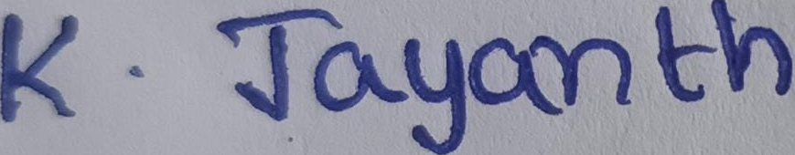
Date : 05-05-2026

Acknowledgement
We would like to express our sincere gratitude to our Honourable Chancellor, Prof.R. Sethuraman, for providing us with the opportunity and the necessary infrastructure to carry out this project as part of our curriculum.
We extend our heartfelt thanks to our Honourable Vice-Chancellor, Dr. S. Vaidhyasubramaniam, and Dr. S. Swaminathan, Dean, Planning & Development, for their constant encouragement and strategic support throughout our academic journey.
We would also like to thank Dr. R. Chandramouli, Registrar for providing us with the opportunity to undertake this project.
We express our sincere appreciation to Dr. K. Thenmozhi, Dean, SEEE; Dr. R. John Bosco Balaguru, Dean (Sponsored Research); and Dr. A. Krishnamoorthy, Associate Dean (Academics), for introducing and facilitating this project as part of our curriculum.
We would like to convey our deep sense of gratitude to our project guide Dr. A. Sriram, Post Doctoral Fellow Research, School of Electrical & Electronics, for his continuous support, valuable guidance, and encouragement throughout the project.
We sincerely thank the Project Review Panel Members Dr. Jayalalitha S, Dr. Susan D for their valuable suggestions and constructive feedback throughout the course of this project. Their insightful observations greatly contributed to improving the quality and depth of our work.
We extend our appreciation to the all the teaching and non-teaching staff of the School of Electrical & Electronics for their support and assistance, directly or indirectly, in the completion of this project.
Finally, we gratefully acknowledge the encouragement and support of our family and friends, which played a vital role in the successful completion of this project.

Abstract
Name: Kandanuri VSNS Jayanth (127180030)
Memory controllers play a vital role in modern digital systems by enabling efficient communication between processors and memory units. In this project, a 64-bit SRAM and SDRAM controller is designed using Verilog HDL with a focus on functional correctness and reliable operation. The conventional controller architecture is implemented using standard control logic to perform read, write, and memory access operations. Functional verification is carried out using Xilinx Vivado through simulation and RTL schematic generation to ensure correct behaviour for various input conditions. The design demonstrates proper memory handling and synchronization, forming a strong foundation for further optimization and implementation in VLSI systems.

Specific Contribution: Design & Simulation

Specific Learning: Verilog HDL, SRAM and SDRAM Controller Design, RTL Design and Simulation, Xilinx Vivado.
Technical Limitations & Ethical Challenges Faced:
• Faced difficulties in verifying correct functionality during RTL design and simulation.
• Encountered issues related to timing mismatches and unexpected switching activity during simulation.
• Ensured proper debugging and validation of SRAM and SDRAM controller operations.
• Maintained originality in coding and avoided copying existing designs
Key words: SRAM Controller, SDRAM Controller, Verilog HDL, RTL Design, Xilinx Vivado


Signature of the student: Signature of the Guide:
Date : 05-05-2026

Abstract
Name: G. Chaya Durga Prasad (127180021)
Power consumption has become a major concern in modern VLSI systems, especially in portable and battery-operated devices. In this project, a low-power optimized 64-bit SRAM and SDRAM controller is developed by incorporating techniques such as clock gating and power gating. These techniques help in reducing unnecessary switching activity and leakage power during idle conditions. The optimized controller design is compared with the conventional implementation to evaluate improvements in power efficiency. Simulation and analysis confirm that the proposed low-power techniques significantly reduce overall power consumption while maintaining correct functionality, making the design suitable for energy-efficient embedded applications.

Specific Contribution: Low Power Optimization
Specific Learning: Low Power Design Techniques (Clock Gating & Power Gating), Power Analysis Concepts, Optimization of Switching and Leakage Power.
Technical Limitations & Ethical Challenges Faced:
• Faced challenges in reducing power consumption while maintaining performance during implementation of clock gating and power gating techniques.
• Difficulty in balancing trade-off between power reduction and correct functionality.
• Managed issues related to unnecessary switching activity and leakage power.
• Followed ethical practices while implementing optimization techniques based on reference ideas.
Key words: Low Power Design, Clock Gating, Power Gating

Signature of the student: Signature of the Guide:
Date : 05-05-2026
Abstract
Name: K. RAVINDRABABU (127180033)
Efficient implementation of digital designs requires proper synthesis and physical design to achieve optimized performance. In this project, the designed 64-bit SRAM and SDRAM controllers are synthesized using Cadence Genus to generate an optimized gate-level netlist. Further, physical design is carried out using Cadence Innovus, including floorplanning, placement, routing, and layout generation. Power analysis is performed to evaluate the effectiveness of the optimized design. The results show that the controller achieves reduced power consumption and efficient layout implementation without major design rule violations, confirming its suitability for low-power VLSI applications.

Specific Contribution: Synthesis & Physical Design

Specific Learning: Cadence Genus, Logic Synthesis, Cadence Innovus, Physical Design Flow.
Technical Limitations & Ethical Challenges Faced:
• Encountered practical limitations related to standard cell libraries and tool constraints during synthesis using Cadence Genus.
• Faced challenges during physical design such as placement, routing, and minor congestion issues in Cadence Innovus.
• Addressed timing violations and ensured design rule checks (DRC/LVS) were error-free.
• Maintained proper design flow and adhered to standard VLSI design practices.
Key words: Cadence Genus, Cadence Innovus, Logic Synthesis, VLSI Design Flow

Signature of the student: Signature of the Guide:
Date : 05-05-2026
Title | Page No
Bona-fide Certificate | ii
Declaration | iii
Acknowledgements | iv
Abstract | v
List of Figures | ix
List of Tables | ix
Abbreviations | x
Notations | x
1.Introduction
1.1 Overview | 1
1.2 Memory Systems in Digital Design | 2
1.3 SRAM and SDRAM Architecture | 3
1.4 Memory Controller Design | 4
1.5 Problem Statement | 5
1.6 Motivation | 5
2.Objectives
2.1 Literature review | 6
2.2 General Objective | 7
2.3 Specific Objectives | 7
3.Methodology
3.1 Design of Existing SRAM and SDRAM Controllers | 9
3.2 Functional Simulation and RTL Verification (Existing Design) | 10
3.3 Proposed Methodology: Low Power Optimization | 11
3.4 Functional Simulation of Optimized Design | 12
3.5 Logic Synthesis using Cadence Genus | 13
3.6 Power Analysis and Comparison | 13
3.7 Physical Design using Cadence Innovus | 13
3.8 Final Layout and Output Generation | 14
4.Results and Discussions
4.1 Functional Verification Results | 15
4.2 Low Power Optimization Results | 15
4.3 Power Analysis and Comparison | 15
4.4 Discussion on Power Reduction | 18
4.5 Physical Design Results | 18
4.6 Discussion | 18
Conclusion | 20
References | 21
Table of Contents
List of Figures
Figure no | Title | Pg. No
1.2.1 | Memory System in Digital System | 2
1.3.1 | SRAM Controller Architecture | 3
1.3.2 | SDRAM Controller Architecture | 4
3.1.1 | Schematic Diagram of SRAM | 9
3.1.2 | Schematic Diagram of SDRAM | 10
3.2.1 | Simulation Waveform of SRAM | 10
3.2.2 | Simulation Waveform of SDRAM | 11
3.3.1 | Schematic Diagram of Optimized SRAM Controller (with sleep, clk_gate, pwr_gate) | 11
3.3.2 | Schematic Diagram of Optimized SDRAM Controller (with power signals) | 12
3.4.1 | Simulation Waveform of Optimized SRAM | 12
3.4.2 | Simulation Waveform of Optimized SDRAM | 13
3.7.1 | Physical Design of SRAM - CADENCE | 14
3.7.2 | Physical Design of SDRAM - CADENCE | 14

List of Tables
Table no | Title | Pg. No
4.3.1 | SRAM Power Comparison (CADENCE) | 16
4.3.2 | SDRAM Power Comparison (CADENCE) | 16

Abbreviations

SRAM | Static Random Access Memory
SDRAM | Synchronous Dynamic Random Access Memory
DDR | Double Data Rate
VLSI | Very Large-Scale Integration
CMOS | Complementary Metal-Oxide Semiconductor
SoC | System on Chip
HDL | Hardware Description Language
RTL | Register Transfer Level
FSM | Design Rule Check
DRC | Layout Versus Schematic
LVS | Graphic Data System II
GDSII | Electronic Design Automation
EDA | Computer Aided Design
Notations

$$P_{total}$$ | Total power consumption
$$P_{leakage}$$ | Leakage (static) power
$P_{internal}$ | Internal power consumption
$P_{switching}$ | Switching (dynamic) power
α | Switching activity factor (0 to 1)
f | Operating frequency

CHAPTER 1
INTRODUCTION
1.1 Overview
Memory is one of the most important components in any digital system, as it is responsible for storing data and instructions required for processing. In modern systems such as embedded devices, processors, and System-on-Chip (SoC) architectures, efficient data transfer between the processor and memory plays a key role in determining overall system performance. This communication is handled by a memory controller, which acts as an interface between the processor and memory units.
Among different types of memory, SRAM (Static Random Access Memory) and SDRAM (Synchronous Dynamic Random Access Memory) are widely used. SRAM provides very fast access speed and is mainly used in cache memory, whereas SDRAM provides higher storage capacity and is used as main memory. Since these two memory types have different working principles and timing requirements, designing an efficient controller that can manage both correctly is a challenging task.
With continuous advancement in VLSI technology and scaling of CMOS devices to deep submicron levels such as 45nm and below, power consumption has become a major concern. In modern applications, especially portable and battery-operated devices, reducing power consumption is as important as maintaining performance. Memory controllers contribute significantly to total system power because of continuous read/write operations and switching activity. Therefore, designing a low-power memory controller is essential for improving overall system efficiency.
In this project, a 64-bit SRAM and SDRAM controller is designed and implemented using Verilog HDL. Initially, a conventional controller design is developed to perform basic memory operations such as read, write, and control signal generation. Then, low-power optimization techniques such as clock gating and power gating are applied to reduce unnecessary switching activity and leakage power during idle conditions.
The design is verified through functional simulation using Xilinx Vivado, where correct operation of the controller is confirmed using test cases and RTL schematics. Further, the design is synthesized using Cadence Genus to obtain an optimized gate-level implementation, followed by physical design using Cadence Innovus, including placement, routing, and layout generation.
Finally, power analysis is carried out to compare the conventional and optimized designs. The results show that the optimized controller significantly reduces power consumption while maintaining correct functionality and efficient memory operation. This makes the proposed design suitable for low-power VLSI and embedded system applications.
1.2 Memory Systems in Digital Design
Memory systems are essential components in digital electronics, used to store data and instructions required for processing. They act as an interface between the processor and storage units, ensuring smooth data flow during execution. Different types of memory are used based on application requirements, such as speed, capacity, and cost. SRAM is typically used for high-speed applications like cache memory, while SDRAM is used for
larger storage in main memory systems. Efficient memory operation requires proper coordination between hardware components, which is handled by the memory controller. Thus, memory systems form the backbone of any computing or embedded system.
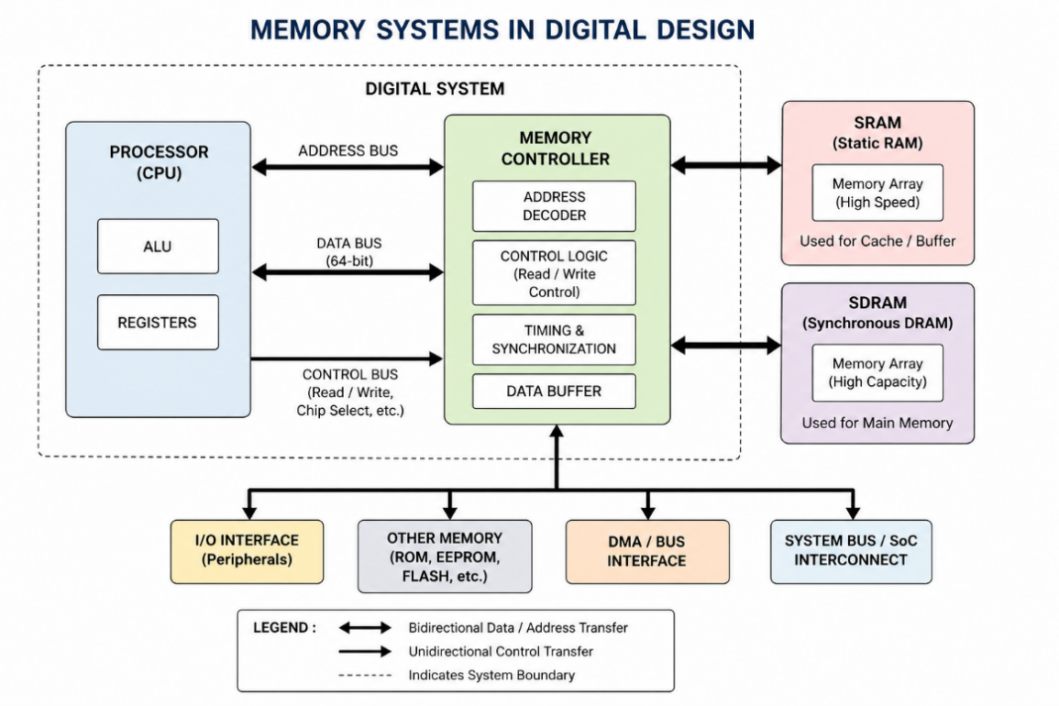
Figure 1.2.1: Memory System in Digital System

1.3 SRAM and SDRAM Architecture
SRAM (Static Random Access Memory) and SDRAM (Synchronous Dynamic Random Access Memory) differ in structure and operation. SRAM uses flip-flop-based storage cells, which provide fast access speed and do not require refresh operations, making it suitable for cache memory. SDRAM, on the other hand, stores data in capacitors and operates synchronously with a clock signal, requiring periodic refresh cycles. While SDRAM offers higher storage density and lower cost, it is comparatively slower than SRAM. In this project, both SRAM and SDRAM controllers are designed to handle their respective memory operations efficiently.

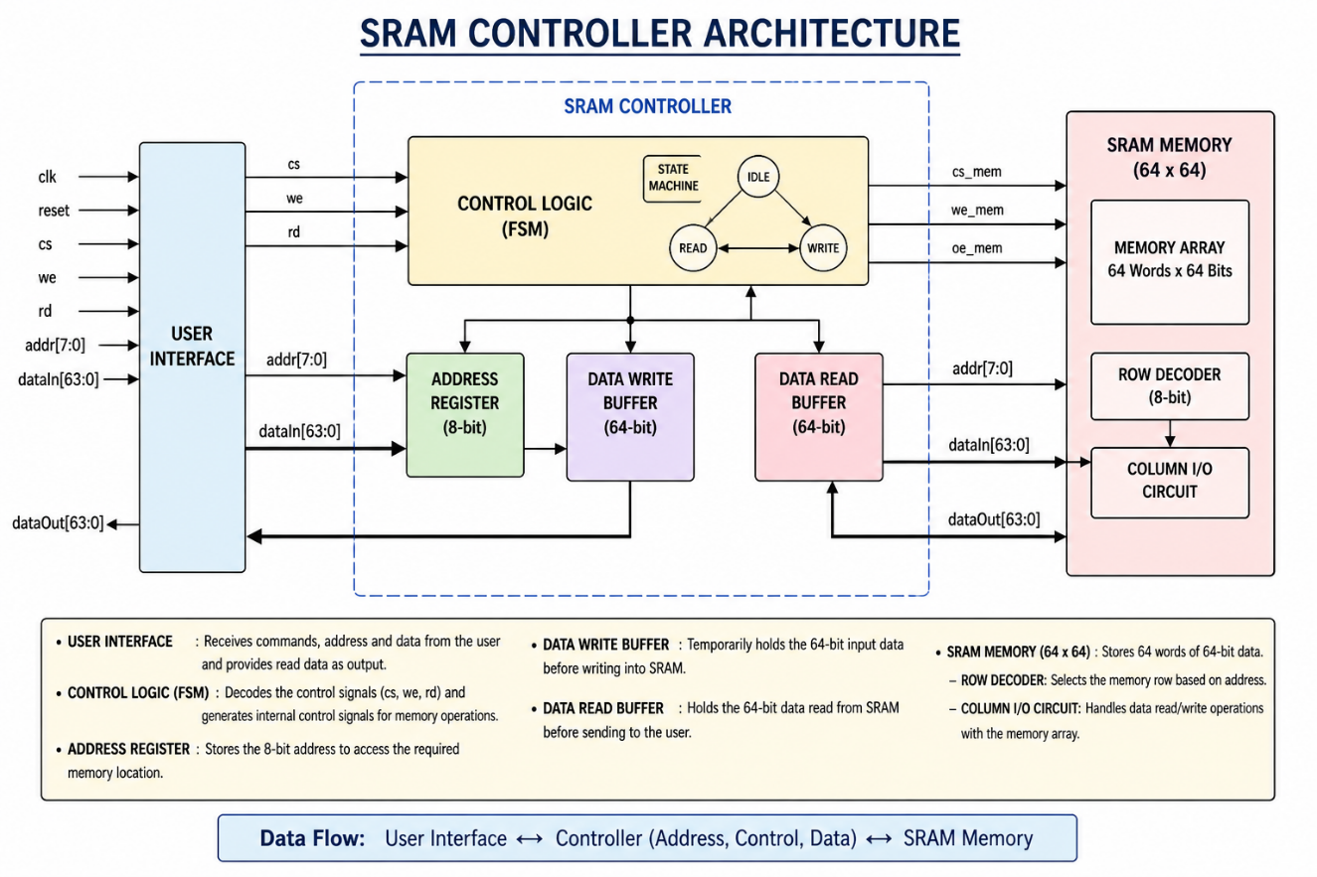
Figure 1.3.1 SRAM Controller Architecture

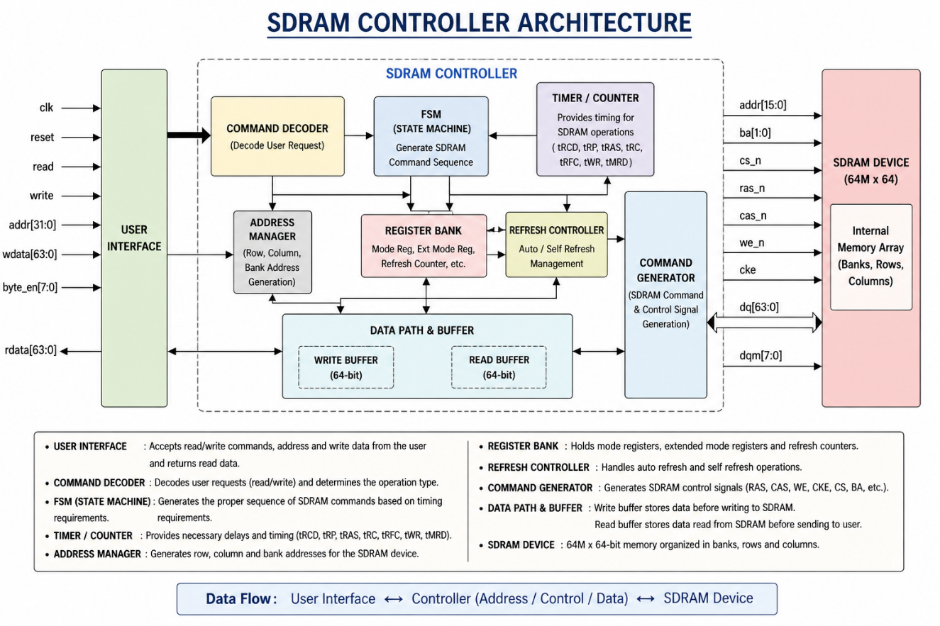
Figure 1.3.2 SDRAM Controller Architecture
1.4 Memory Controller Design
A memory controller is a crucial component that manages communication between the processor and memory devices. It is responsible for generating control signals for read, write, and address operations, ensuring proper timing and synchronization of data transfer. The controller also performs functions such as memory initialization, access management, and coordination of data flow between different system components.
In this project, 64-bit SRAM and SDRAM controllers are designed using Verilog HDL to support efficient memory operations. The design incorporates control logic for handling read and write processes, along with address decoding and data management mechanisms to ensure reliable communication between the processor and memory units.
The SRAM and SDRAM controller architectures used in this design are shown in Figure 1.3.1 and Figure 1.3.2, which illustrate the basic control logic and data flow between the memory and processor. Functional simulation and RTL verification are carried out to validate the correctness and performance of the controller design.

1.5 Problem Statement
In many existing systems, SRAM and SDRAM controllers are primarily designed for high performance without focusing on power efficiency. This results in increased power consumption due to continuous switching activity and inefficient utilization of resources. Such designs are not suitable for modern applications like portable and battery-operated devices, where power optimization is critical. Therefore, there is a need to design a 64-bit SRAM and SDRAM controller that reduces power consumption while maintaining correct functionality and efficient memory operation.
1.6 Motivation
The increasing demand for energy-efficient electronic systems has made low-power design an important aspect of VLSI development. Memory controllers contribute significantly to overall system power consumption due to frequent data access operations. Reducing power consumption not only improves battery life in portable devices but also enhances system reliability and thermal performance. This motivates the implementation of low-power techniques such as clock gating and power gating in memory controller design. The goal of this project is to develop an optimized controller that balances performance and power efficiency for modern digital systems.

CHAPTER 2
LITERATURE REVIEW AND OBJECTIVES
2.1 Literature Review
2.1.1 Design of 64-bit SRAM and SDRAM Controller (Rugma et al., 2024)
A 64-bit SRAM and SDRAM controller was designed using SCL 180 nm technology by following the complete VLSI design flow, including RTL design, synthesis, and physical design using Cadence tools. The design ensured proper memory communication and reliable data transfer between processor and memory units. This work provided a strong foundation for understanding the complete design flow and guided the implementation of SRAM and SDRAM controllers in this project.
2.1.2 AI-Enabled Reconfigurable SRAM Controller (Shaila et al., 2025)
An AI-based reconfigurable SRAM controller was proposed to improve efficiency and reduce latency in memory operations. The system utilized adaptive techniques for optimized memory access and enhanced performance. Although the approach improved flexibility, it introduced additional design complexity. This study helped in understanding advanced controller optimization techniques and the importance of efficient data handling in memory systems.
2.1.3 DDR SDRAM Controller using Verilog HDL (Kumar & Onker, 2023)
A DDR SDRAM controller was designed and verified using Verilog HDL, incorporating essential memory operations such as initialization, read/write cycles, and refresh mechanisms. The design focused on proper timing control and synchronization required for dynamic memory systems. This work provided insights into SDRAM operation and guided the implementation of timing control logic in this project.
2.1.4 FSM-Based SRAM Controller Design (Tigadi & Guhilot, 2025)
An SRAM controller was implemented using a finite state machine (FSM)-based architecture to simplify control logic and reduce hardware complexity. The design achieved efficient memory operations with structured control flow. This approach helped in developing organized control logic for SRAM operations in the proposed design.
2.1.5 DDR SDRAM Controller for Embedded Systems (Latti, 2019)
A DDR SDRAM controller was developed for embedded system applications with emphasis on improving data throughput and efficient memory management. The design highlighted techniques for handling high-speed data transfer and memory access optimization. This study contributed to understanding memory handling strategies in embedded systems.
2.2 General Objective
To design and implement a 64-bit SRAM and SDRAM controller capable of performing efficient read, write, and memory management operations with reduced power consumption.
2.3 Specific Objectives
a. Controller Design and Functional Implementation
• To design SRAM and SDRAM controllers using Verilog HDL.
• To implement control logic for handling read, write, and address operations.
• To ensure proper data flow and synchronization between processor and memory units.
b. Functional Simulation and Verification
• To perform functional simulation using Xilinx Vivado.
• To generate RTL schematics and verify correct operation for different input conditions.
• To validate controller functionality through waveform analysis.
c. Low Power Optimization Techniques
• To implement clock gating to reduce unnecessary switching activity.
• To apply power gating to minimize leakage power during idle conditions.
• To analyze the trade-off between power reduction and performance.

d. Logic Synthesis and Power Analysis
• To synthesize the design using Cadence Genus to obtain optimized gate-level netlist.
• To perform power analysis and compare conventional and optimized designs.
• To evaluate improvements in dynamic and static power consumption.
e. Physical Design Implementation
• To perform physical design using Cadence Innovus including floorplanning, placement, and routing.
• To ensure design rule correctness through DRC and LVS verification.
• To generate the final layout in GDSII format.
f. System Evaluation and Performance Analysis
• To compare the performance of existing and optimized controllers.
• To analyze results in terms of power consumption and functionality.
• To ensure the design meets requirements for low-power VLSI applications.
CHAPTER 3
METHODOLOGY
3.1 Design of Existing SRAM and SDRAM Controllers
In the first stage of the project, we designed the existing 64-bit SRAM and SDRAM controllers using Verilog HDL in Xilinx Vivado. The controllers are developed to perform basic memory operations such as read, write, and address handling using control signals like chip select (cs), write enable (we), and read enable (rd). The SRAM controller is designed for fast memory access with simple control logic, whereas the SDRAM controller includes additional synchronization and state-based control to manage timing requirements. The RTL schematic generated in Vivado clearly shows the internal structure, data flow, and interaction between different blocks of the controller.

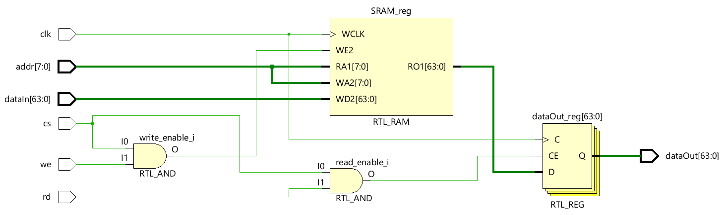
Figure 3.1.1: Schematic Diagram of SRAM
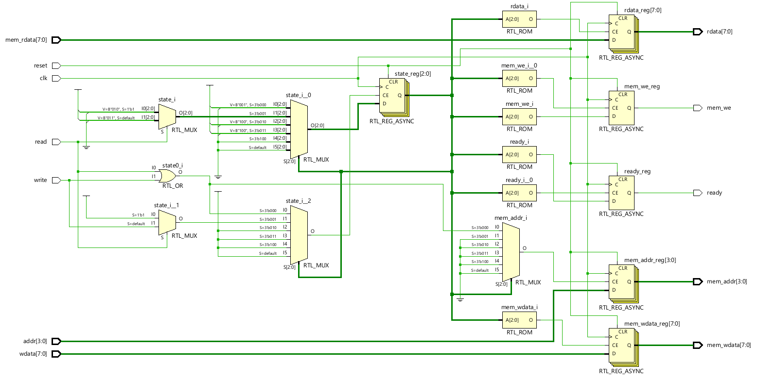
Figure 3.1.2: Schematic Diagram of SDRAM
3.2 Functional Simulation and RTL Verification (Existing Design)
After designing the controllers, functional simulation is performed in Xilinx Vivado to verify correct operation under different input conditions. Various test cases are applied to check read and write functionality, address selection, and control signal behaviour. The simulation waveforms confirm that the controllers correctly transfer data between input and output based on the control signals. The RTL verification ensures that the internal logic is working as expected and there are no functional errors in the design before optimization.
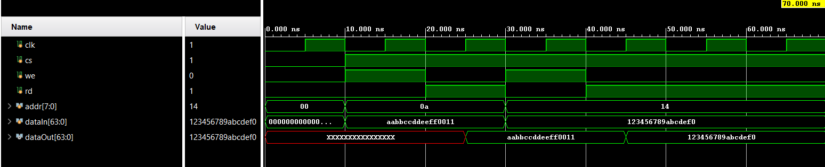
Figure 3.2.1: Simulation Waveform of SRAM
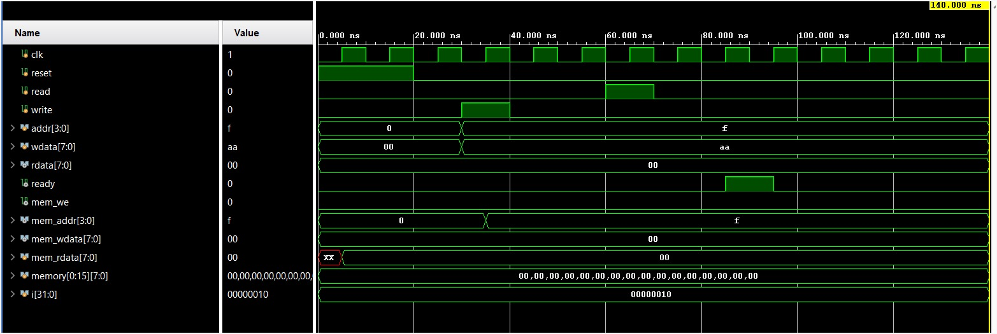
Figure 3.2.2 Simulation Waveform of SDRAM
3.3 Proposed Methodology: Low Power Optimization
After verifying the existing design, low-power optimization techniques are implemented to reduce overall power consumption. Techniques such as clock gating are used to disable the clock signal during idle conditions to reduce switching activity, while power gating is applied to shut down inactive parts of the circuit to minimize leakage power. Additionally, memory enable and disable logic is introduced to activate memory only when required. These modifications improve power efficiency without affecting the functionality of the controllers.
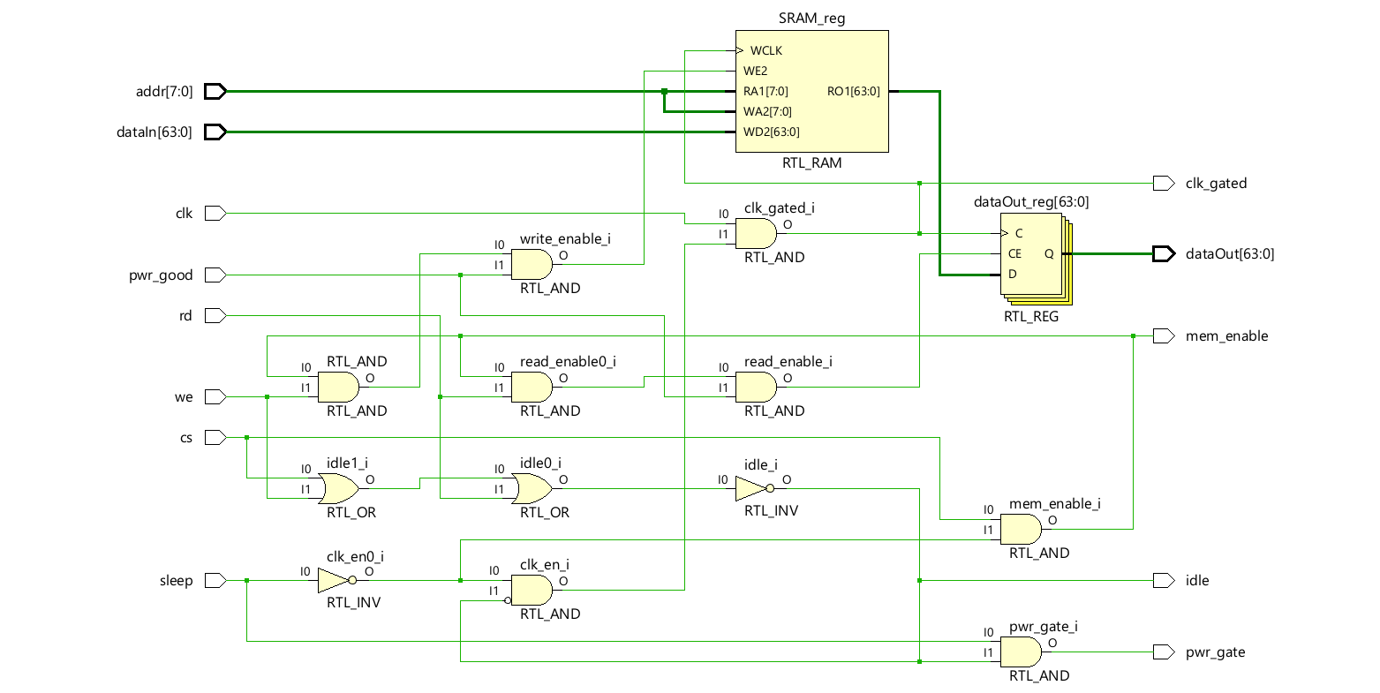
Figure 3.3.1: Schematic Diagram of Optimized SRAM Controller (with sleep, clk_gate, pwr_gate)
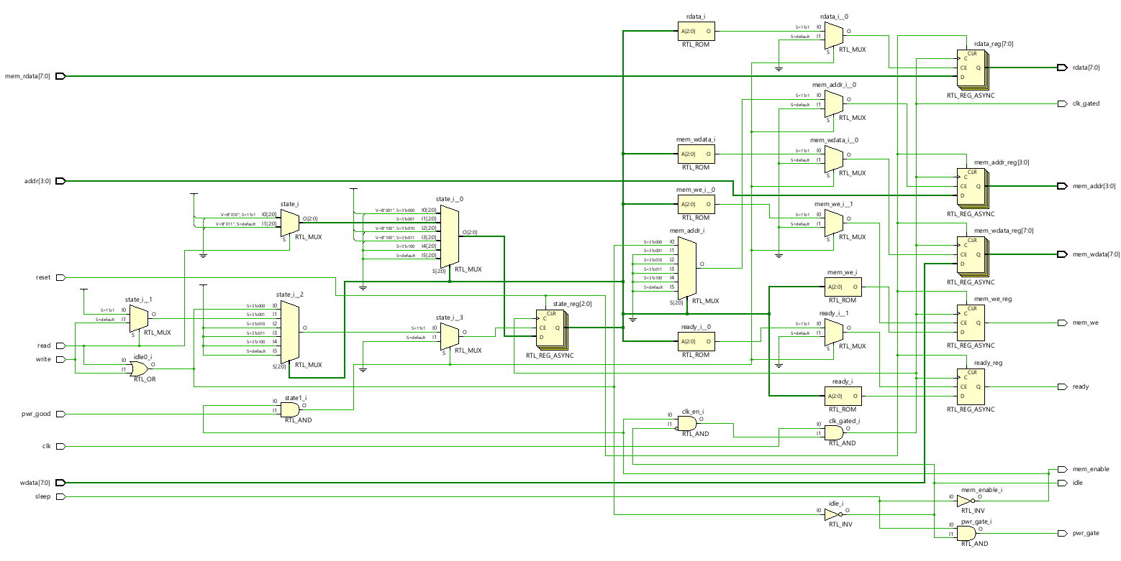
Figure 3.3.2: Schematic Diagram of Optimized SDRAM Controller (with power signals)
3.4 Functional Simulation of Optimized Design
After applying low-power techniques, the modified SRAM and SDRAM controllers are again simulated using Xilinx Vivado to verify that the functionality remains correct. The waveform results show that the read and write operations are performed correctly even after adding clock gating and power gating logic. It also confirms that clock activity is reduced during idle conditions and power control signals work properly without affecting data output. This ensures that optimization does not introduce any errors in the system.

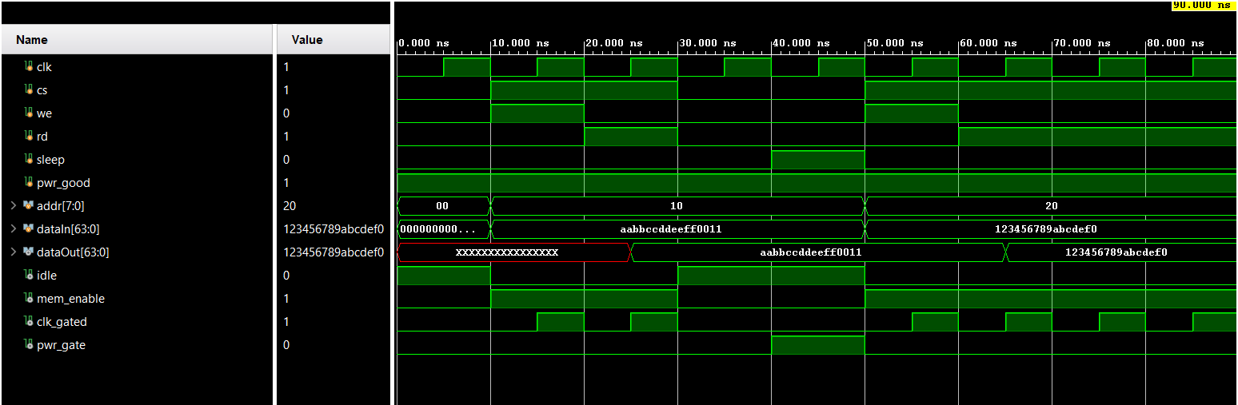
Figure 3.4.1: Simulation Waveform of Optimized SRAM

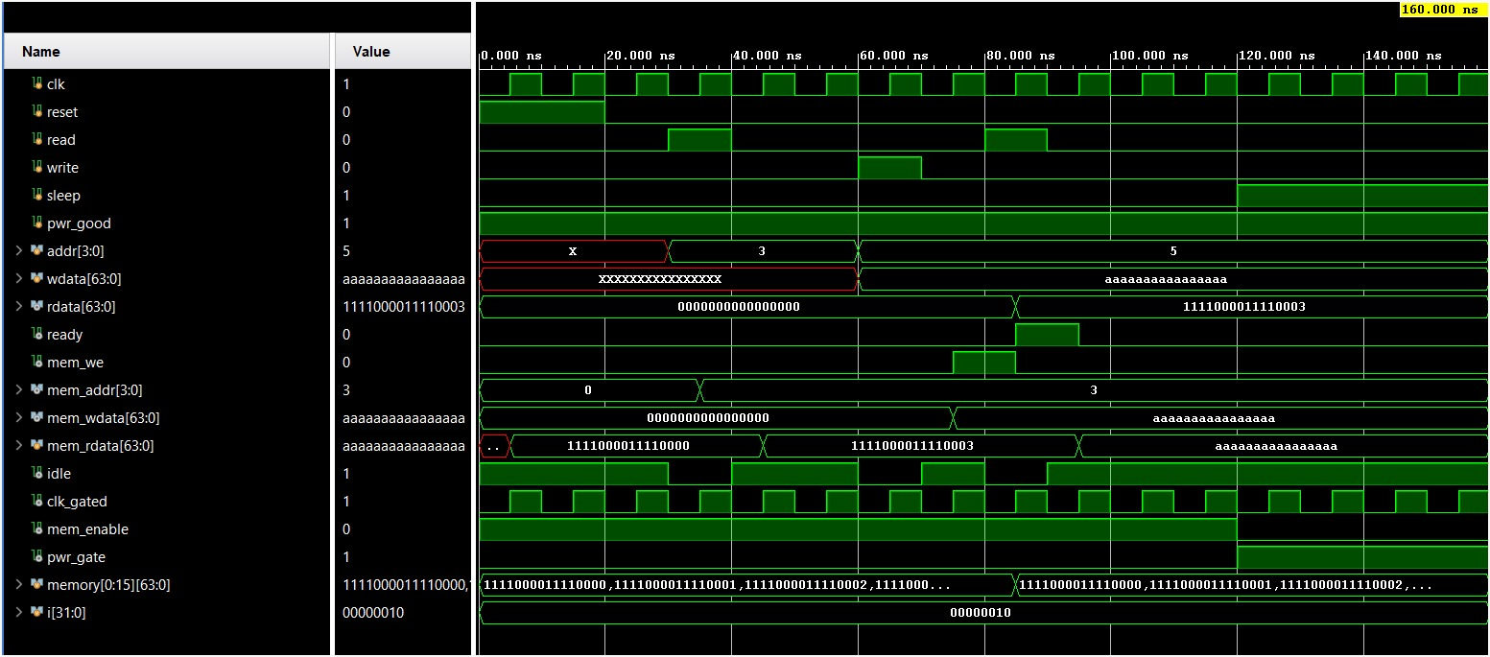
Figure 3.4.2: Simulation Waveform of Optimized SDRAM
3.5 Logic Synthesis using Cadence Genus
Once the design is verified through simulation, it is synthesized using Cadence Genus to convert the RTL design into a gate-level netlist. During synthesis, the tool optimizes the design for better performance, reduced area, and lower power consumption. It also generates reports related to timing, area, and power, which are useful for evaluating the efficiency of both existing and optimized designs. This step prepares the design for further physical implementation.
3.6 Power Analysis and Comparison
Power analysis is carried out to compare the performance of conventional and optimized controllers. Parameters such as leakage power, internal power, switching power, and total power are analysed. The comparison clearly shows that the optimized design significantly reduces power consumption.
3.7 Physical Design using Cadence Innovus
After synthesis, the gate-level design is implemented physically using Cadence Innovus. This stage includes floorplanning, placement of standard cells, clock tree synthesis, and routing of interconnections. The goal is to create an optimized physical layout while satisfying timing, power, and area constraints. The generated layout visually represents how the design is implemented on silicon, including all connections and components.
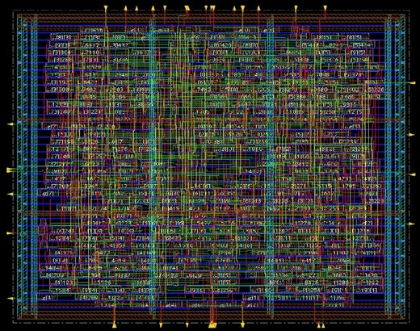
Figure 3.7.1: Physical Design of SRAM - CADENCE
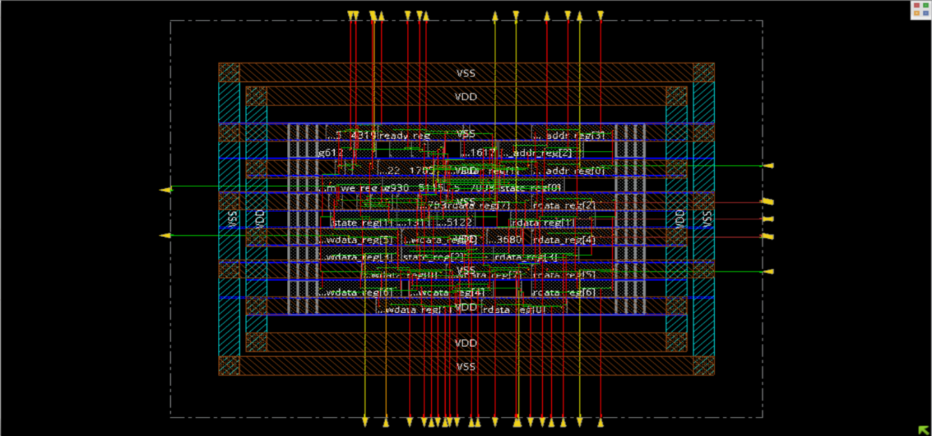
Figure 3.7.2: Physical Design of SDRAM - CADENCE
3.8 Final Layout and Output Generation
In the final stage, the design is verified using Design Rule Check (DRC) and Layout Versus Schematic (LVS) to ensure correctness and reliability of the physical implementation. After successful verification, the final layout is generated in GDSII format, which is used for fabrication. The overall design confirms that the optimized SRAM and SDRAM controllers achieve reduced power consumption while maintaining correct functionality, making them suitable for low-power VLSI applications.

CHAPTER 4
RESULTS AND DISCUSSIONS

4.1 Functional Verification Results
The designed SRAM and SDRAM controllers are functionally verified using simulation in Xilinx Vivado. Different input conditions are applied to validate read and write operations, address handling, and control signal generation. The simulation results confirm correct functionality and proper synchronization of memory operations.
The simulation waveforms of SRAM and SDRAM controllers are shown in Figure 3.2.1 and Figure 3.2.2, respectively. These results demonstrate correct data transfer and expected behaviour of the controller under various input conditions.
4.2 Low Power Optimization Results
Low-power techniques such as clock gating and power gating are implemented to reduce unnecessary switching activity and leakage power. The optimized controllers include additional signals such as sleep, clk_gated, and pwr_gate, which help in disabling inactive blocks and improving power efficiency.
The modified SRAM and SDRAM controller architectures with low-power techniques are shown in Figure 3.3.1 and Figure 3.3.2, respectively. These figures illustrate the additional control logic introduced for power optimization.
4.3 Power Analysis and Comparison
Power analysis is performed using Cadence Genus to evaluate the effectiveness of the optimized design. Parameters such as leakage power, internal power, switching power, and total power are analysed.
From Table 4.3.1, the optimized SRAM controller shows a significant reduction in total power consumption of approximately 41.5%, mainly due to reduction in internal and switching power. A slight increase in leakage power is observed due to additional gating circuitry.
From Table 4.3.2, the optimized SDRAM controller achieves approximately 49.3% reduction in total power consumption. The results indicate effective reduction in both internal and leakage power components.

Table 4.3.1: SRAM Power Comparison (CADENCE)
Parameter | Existing SRAM Controller | Optimized SRAM Controller | Improvement
Leakage Power(mW) | 0.011 | 0.011 | Slight Increase
Internal Power(mW) | 15.479 | 8.778 | Reduced
Switching Power(mW) | 1.064 | 0.894 | Reduced
Total Power (mW) | 16.554 | 9.683 | Reduced (~41.5%)

Table 4.3.2: SDRAM Power Comparison (CADENCE)
Parameter | Existing SDRAM Controller | Optimized SDRAM Controller | Improvement
Leakage Power (µW) | 3.886 | 0.020 | Reduced
Internal Power (µW) | 107.268 | 24.176 | Reduced
Switching Power (µW) | 8.756 | 36.610 | Increased
Total Power (µW) | 119.911 | 60.806 | Reduced (~49.3%)

Formulas:
1.Leakage Power:
$P_{leakage}$=$I_{leakage}$ ​×$V_{dd}$
$I_{leakage}$= Leakage current (due to subthreshold, gate leakage)
$V_{dd}$= Supply voltage
2.Internal Power:
$P_{internal}$​≈α⋅$C_{int}$​⋅$V_{dd}$²​⋅f
$C_{int }$= Internal capacitance of gates
$α$= Switching activity
$f$= Frequency
3.Switching Power:
$P_{switching}$​ = α⋅C_{L}⋅$​V_{dd}$​ ²⋅f
α= Switching activity factor (0 to 1)
$C_{L }$= Load capacitance
$V_{dd}$= Supply voltage
$f$= Operating frequency
4.Total Power:
Total Power = Leakage Power + Internal Power + Switching Power
$P_{total}$​ = $I_{leakage}​$⋅$V_{dd}$​+α⋅ $C_{L}⋅​V_{dd}$²​⋅f+α⋅$C_{int}⋅​V_{dd}$²⋅​f

4.4 Discussion on Power Reduction
The results clearly indicate that the implementation of clock gating reduces dynamic power by minimizing switching activity, while power gating effectively reduces leakage power during idle conditions. The combination of these techniques results in a significant reduction in total power consumption.
Although a slight increase in leakage power is observed in the SRAM controller due to added gating logic, the overall power reduction is substantial. The SDRAM controller shows better improvement due to efficient control logic and reduced switching activity.
4.5 Physical Design Results
The physical design of the SRAM and SDRAM controllers is carried out using Cadence Innovus. The process includes floorplanning, placement, clock tree synthesis, and routing.
The final layouts of the SRAM and SDRAM controllers are shown in Figure 3.7.1 and Figure 3.7.2, respectively. These layouts represent the arrangement of standard cells, interconnections, and clock distribution network in the design. The layouts are verified using DRC and LVS checks to ensure correctness and reliability.
4.6 Discussion
The project work began with the study of a base reference design and understanding of SRAM and SDRAM controller architectures, as illustrated in Figure 1.3.1 and Figure 1.3.2 During implementation, practical constraints related to standard cell libraries and available design tools were encountered, which required careful design adjustments.
Both SRAM and SDRAM controllers were successfully designed and implemented using Verilog HDL. The design was verified through functional simulation and RTL validation using Xilinx Vivado, as shown in Figure 3.2.1 and Figure 3.2.2, confirming correct read and write operations.
Low-power optimization techniques such as clock gating and power gating were applied, and the modified controller architectures are shown in Figure 3.3.1 and Figure 3.3.2. These modifications help in reducing unnecessary switching activity and leakage power.
The comparison between existing and modified controllers shows that the optimized design achieves significant reduction in total power consumption while maintaining correct functionality. The results confirm that the use of low-power techniques improves overall efficiency without affecting system performance.
The complete VLSI design flow, including RTL design, synthesis using Cadence Genus, and physical design using Cadence Innovus, was successfully implemented. The final layout of the SRAM and SDRAM controllers is shown in Figure 3.7.1 and Figure 3.7.2, demonstrating successful physical implementation with proper placement and routing.

CONCLUSION
In this project, a 64-bit SRAM and SDRAM controller was successfully designed and implemented using Verilog HDL with a focus on low-power optimization. The conventional controller design was initially developed and verified, which produced correct functionality but exhibited higher power consumption due to increased switching activity.
To overcome this limitation, low-power techniques such as clock gating and power gating were incorporated into the design. These techniques effectively reduced unnecessary switching activity and leakage power during idle conditions. The optimized controllers maintained correct functionality while achieving significant reduction in total power consumption.
Functional verification was carried out using Xilinx Vivado, where simulation results confirmed proper read and write operations along with correct control signal generation. Further, the design was synthesized using Cadence Genus, and physical implementation was performed using Cadence Innovus. The generated layouts demonstrated successful placement and routing, ensuring that the design meets timing and physical constraints.
Power analysis results clearly indicate that the optimized SRAM and SDRAM controllers achieve considerable reduction in total power consumption compared to conventional designs. Although a slight increase in leakage power is observed in some cases due to additional gating circuitry, the overall power efficiency is significantly improved.
Thus, the proposed design demonstrates improved performance, reduced power consumption, and reliable operation, making it suitable for low-power VLSI and embedded system applications. The project successfully validates the effectiveness of clock gating and power gating techniques in designing energy-efficient memory controllers.

REFERENCES
1. Kumar, P., & Onker, S. (2023, June). A comprehensive study of design and verification of DDR SDRAM controller using Verilog. In IJERT International Conference on Engineering Research & Technology (pp. 1–5).
2. Latti, S. (2019, March). Design and implementation of DDR SDRAM controller for embedded processors. In International Conference on Electronics and Communication Engineering (pp. 1–6).
3. Rugma, A. S., Sreelatha, G., & Adersh, V. R. (2024, December). Design and implementation of 64-bit SRAM and SDRAM controller in SCL 180 nm technology. In 2024 IEEE International Conference on Smart Electronics and Communication Systems (ISENSE) (pp. 1–6).
4. Shaila, C. K., Bella Mary, I. T., Divya, P. S., Vinodhini, A., Manoj, G., & Naveen Sundar, G. (2025, January). Design and verification of AI-enabled reconfigurable SRAM controller for automobile applications. In International Conference on Advanced Computer Science and Applications (pp. 1–5).
5. Tigadi, A., & Guhilot, H. (2025, February). Design and implementation of SRAM controller on reconfigurable platform, International Conference on Engineering and Advanced Technology (pp. 1–6).

